Covariance and Correlation
Covariance and correlation are the two key concepts in Statistics that help us analyse the relationship between two variables. Covariance measures how two variables change together, indicating whether they move in the same or opposite directions.
To understand this relationship better, consider factors like sunlight, water and soil nutrients (as shown in the image), which are independent variables that influence plant growth our dependent variable. Covariance measures how these variables change together, indicating whether they move in the same or opposite directions.
What is Covariance?
Covariance measures how two random variables change together. It is calculated by averaging the product of their deviations from their means. A positive value means they move in the same direction, while a negative value means they move in opposite directions.
- It can take any value between - infinity to +infinity, where the negative value represents the negative relationship whereas a positive value represents the positive relationship.
- It is used for the linear relationship between variables.
- It gives the direction of relationship between variables.
Covariance Formula
1. Sample Covariance
COVs (X,Y) = $\frac{1}{n-1}\sum_{i=1}^{n}{\left(x_{i}-\overline{x}\right)\left(y_{i}-\overline{y}\right)}$
Where:
- ​$x_{i}$: The value of the variable in the sample.
- ​$y_{i}$: The value of the variable in the sample.
- $\overline{x}$: The sample mean of variable (i.e., the average of all ​ values in the sample).
- $\overline{y}$: The sample mean of variable (i.e., the average of all ​ values in the sample).
- n: The number of data points in the sample.
- ∑: The summation symbol means we sum the products of the deviations for all the data points.
- n-1: This is the degrees of freedom. When working with a sample, we divide by n-1 to correct for the bias introduced by estimating the population covariance based on the sample data. This is known as Bessel's correction.
2. Population Covariance
COVp (X,Y) = $\frac{1}{n-1}\sum_{i=1}^{n}{\left(x_{i}-µx\right)\left(y_{i}-µy\right)}$
Where:
- ​$x_{i}$: The value of the variable in the population.
- ​$y_{i}$: The value of the variable in the population.
- $µx$: The population mean of a variable (i.e., the average of all ​ values in the population).
- $µy$: The population mean of a variable (i.e., the average of all ​ values in the population).
- n: The total number of data points in the population.
- ∑: The summation symbol means we sum the products of the deviations for all the data points.
- n: In the case of population covariance, we divide by because we are using the entire population data. There’s no need for Bessel’s correction since we’re not estimating anything.
Types of Covariance
- Positive Covariance: When one variable increases, the other variable tends to increase as well and vice versa.
- Negative Covariance: When one variable increases, the other variable tends to decrease.
- Zero Covariance: There is no linear relationship between the two variables; they move independently of each other.
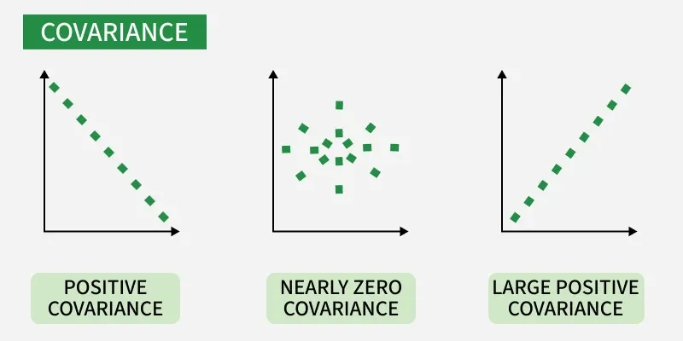
What is Correlation?
Correlation is a standardized measure of the strength and direction of the linear relationship between two variables. It is derived from covariance and ranges between -1 and 1. Unlike covariance, which only indicates the direction of the relationship, correlation provides a standardized measure.
- Positive Correlation (close to +1): As one variable increases, the other variable also tends to increase.
- Negative Correlation (close to -1): As one variable increases, the other variable tends to decrease.
- Zero Correlation: There is no linear relationship between the variables.
The correlation coefficient for variables X and Y is defined as:
- Correlation takes values between -1 to +1, wherein values close to +1 represents strong positive correlation and values close to -1 represents strong negative correlation.
- In this variable are indirectly related to each other.
- It gives the direction and strength of relationship between variables.

Correlation Formula

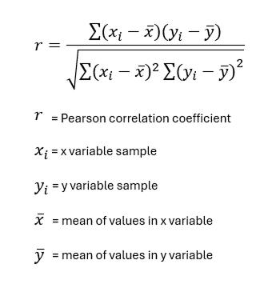

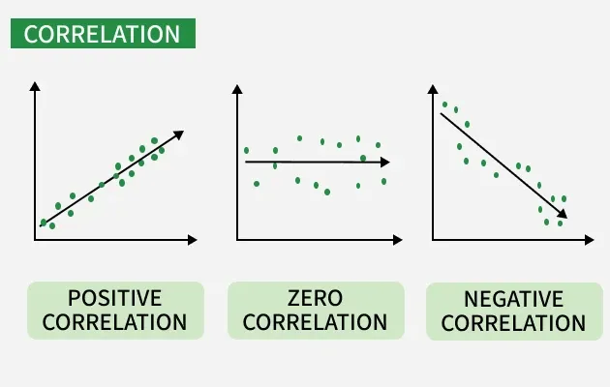

Difference between Covariance and Correlation
This table shows the difference between Covariance and Covariance:
Covariance | Correlation
Covariance is a measure of how much two random variables vary together | Correlation is a statistical measure that indicates how strongly two variables are related.
Involves the relationship between two variables or data sets | Involves the relationship between multiple variables as well
Lie between -infinity and +infinity | Lie between -1 and +1
Measure of correlation | Scaled version of covariance
Provides direction of relationship | Provides direction and strength of relationship
Dependent on scale of variable | Independent on scale of variable
Have dimensions | Dimensionless
They key difference is that Covariance shows the direction of the relationship between variables, while correlation shows both the direction and strength in a standardized form.
Applications of Covariance and Correlation
Applications of Covariance
- Portfolio Management in Finance: Covariance is used to measure how different stocks or financial assets move together, aiding in portfolio diversification to minimize risk.
- Genetics: In genetics, covariance can help understand the relationship between different genetic traits and how they vary together.
- Econometrics: Covariance is employed to study the relationship between different economic indicators, such as the relationship between GDP growth and inflation rates.
- Signal Processing: Covariance is used to analyze and filter signals in various forms, including audio and image signals.
- Environmental Science: Covariance is applied to study relationships between environmental variables, such as temperature and humidity changes over time.
Applications of Correlation
- Market Research: Correlation is used to identify relationships between consumer behavior and sales trends, helping businesses make informed marketing decisions.
- Medical Research: Correlation helps in understanding the relationship between different health indicators, such as the correlation between blood pressure and cholesterol levels.
- Weather Forecasting: Correlation is used to analyze the relationship between various meteorological variables, such as temperature and humidity, to improve weather predictions.
- Machine Learning: Correlation analysis is used in feature selection to identify which variables have strong relationships with the target variable, improving model accuracy.

